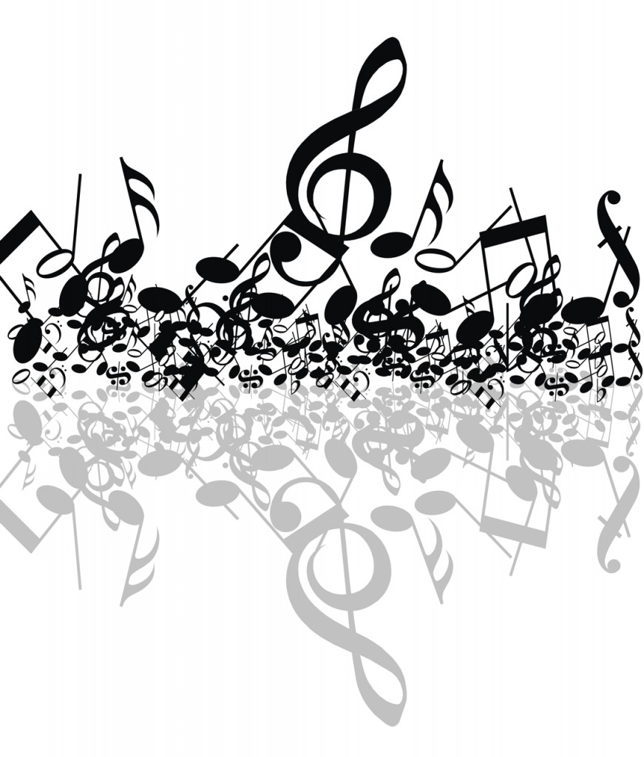
Collinsville Bands
Middle School Spring Concert
Thursday, May 2, 2018
Collinsville Middle School Gymnasium 7 p.m.

Band Directors
Rod Mackey
Tyler Simmons
TJ Smith

Administration
Superintendent – Lance West
H.S. Principal – Scott Kiker
J.H. Principal – Dale Harp
6th Grade Principal – Chris Bilyeu
Program
6th Grade Band
Heritage and Reflection…….……….……………Patrick Roszell
The Tempest……………………….……………….Robert W. Smith

Flute
Aiden Deatherage
Lexi Kealiher
Brooke Myers
Addie Jo Fritts
Carla Hartley
Emily Jurado-Wilson
Elizabeth Sprangel
Nayeli Wray
Abigail Jackson
Owen Laramore
Oboe
Landon Monkress
Clarinet
Eric Evans
Rosa Gray
Serenity Bundy
Nick Downard
Britton Dye
Jordyn Gray
Savita Moua
Rylee Nunes
Addison Roper
Taybri Tucker
Camaron Wells
Emma Baysinger
Alto Sax
Mia Morrison
Levi Cooper
Tenor Sax
Carter Richie
Trumpet
Jackson Bratcher
Cody Carlson
Tag Goodrich
Laney Grigg
Andrew Kiefer
Connor McGarrah
Grant Myers
Caden Ramos
Aiden Reichenberger
Kaiden Stokoe
Carter Zibell
Drake DeVore
Jaden Graham
French Horn
Bryce Davis
Maddux Hurd
Trombone
Spencer Cupps
Alex Escobedo
Brycen gosney
Hannah Roberts
Shelby Root
Jack White
Joey Cousimano
Peyton Hudson
Lily Wingate
Alejandro Perez
Euphonium
Jackson Stehl
Logan Limbocker
Tuba
David Hines
Trevor Ramon
Percussion
Bentley Brown
Tristan Clark
Kierra Getz
Michael Mapp
Sophi Marler
Celina Thor
Jonah Yates
Jaxon Wilson
Brody Williams

7th Grade Band
Flourish……………….……….Larry Clark and Sandy Feldstein
Funkytown………….………………………………………..Ralph Ford
Flash in the Pan!……………….…………………Richard Saucedo

Flute
Sophia Baker
Ryan Boatman
Julia Gibbs
Julie Nichol
Oboe
Isabella Sokol
Clarinet
Will Lester
Alex Bowlin
Ashlynn Comstock
Chyenne Brewer
Skyler Parker
Alto Sax
Savannah Hutchens
Hayden Evans
Bassoon
Nikki Lovell
Trumpet
Trevor Harris
Jennifer Reeder
French Horn
Landry Warder
Trombone
Jackson Vickers
Drew Mazzanti
Gabe Houts
Edward Seiter
Tuba
Ethan Stealer
Percussion
Lauren Grogg
Madi Cook
Ava Bowler
Hunter Graybill
Stryder Mickelson

Jazz Ensemble 3
Front Burner……………………….………….Sammy Nestico
Quality Time…………………………………….Greg Yasinisky
“A” rock………………………………………………….Ken Harris

Alto Sax
Savanna Hutchens
Ashlynn Comstock
Allie Brackett
Bryden Lovan
Tenor Sax
Geralynn Barnett
Will Lester
Killian Metcalf
Camden Thomason

Bari Sax
Makayla Jones
Trombone
Alex Oder
Adam Terry
Drew Mazzanti
Dawson Gilreath
Ethan Stealer
Matt Ball
Trumpet
Brenden Marler
Brooke Oliver
Irvin Rosales
Diego Mejia
Andrew Downing
Drums
Lauren Grogg
Bass
Ammon DeRoussell
Piano
Caleb Wheeler

8th Grade Band
American Legion March.………………………..Andrew Glover
Cumberland Cross………………..…..………..….Carl Strommen
All Star……………...………..………Greg Camp, arr. Mike Story

Flute
Allie Brackett
Killian Metcalf
Oboe
Sam Salley
Clarinet
Carter Mazzanti
Hailey Pena
Brayden Lovan
Alto Saxophone
Tate Getz
Hunter James
Tenor Sax
Geralynn Barnett
Trumpet
Mason Crabaugh
Caleb Wheeler
Connor Duncan
Irvin Rosales
Andrew Downing
French Horn
Brandon Hobbs
Trombone
Alex Oder
Cole Wilkinson
Tuba
Dawson Gilreath
Logan Morrison
Percussion
Spencer Lovell
Emma Cheatham
A’mya Canady

