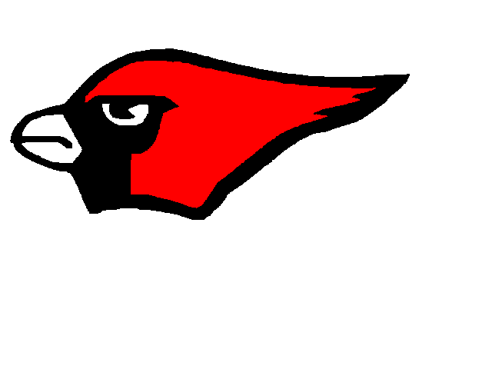
COLLINSVILLE CARDINAL
2014 Football Schedule

VARSITY (All games begin at 7:00 p.m.) JV (All games begin at 6:30 p.m. unless noted)

Aug. 22 Scrim. - @ Bartlesville
Aug. 28 Scrim. - @ Collinsville vs. Claremore

Sept. 4 vs. Oologah (H) (Thurs.) Sept. 8 Oologah (A)
Sept. 12 vs. Catoosa (H) Sept.15 vs. Catoosa (A)
Sept. 19 vs. Skiatook (A) Sept. 22 vs. Skiatook (H) 6:00
Sept. 26 vs. Coweta (A) Sept. 29 vs. Coweta (H)
Oct. 3 vs. Tahlequah (H) (Homecoming) Oct. 6 vs. Tahlequah (A)
Oct. 10 vs. Grove (A) Oct.13 Grove (H)
Oct. 16 vs. Edison (H) Oct. 20 vs. Edison (A)
Oct. 24 vs. Open
Oct. 31 vs. Pryor (A)
Nov. 7 vs. East Central (H)
Nov. 14 - 1st Round Playoffs
Nov. 21 - 2nd Round Playoffs
Nov. 28/29 - State Semifinals
Dec. 5/6 - State Championship

Junior High (7th grade begins at 5:00 p.m. unless noted)

Sept. 2 vs. Oologah (H)
Sept.11 vs. Claremore (A)
Sept.18 vs. Pryor (H)
Sept. 25 vs. Tahlequah (A)
Oct. 2 vs. Ponca City (A)
Oct. 9 vs. Grove (H)
Oct. 14 Fall Break
Oct. 23 vs. Skiatook (A)
Oct. 30 vs. Coweta (H)
JH Scrimmages TBA at a later date.

