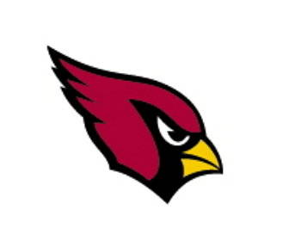
When: July 24th & 25th
Grades: 4th, 5th, & 6th
Time: 6:30pm - 8:30pm
Location: Sallee Field

About the camp: The Cardinal Football Camp will consist of football fundamentals with personal instruction from the Varsity Coaching Staff and selected high school players. The camp is a contact camp and each player is required to wear a helmet and shoulder pads.

What to bring: Campers will need to dress in shorts, T-shirt, and athletic shoes. Cleats are recommended. Helmets, mouthpieces, and shoulder pads are required. Water and Gatorade will be provided.

Cost: $40.00 per camper. Price includes a cardinal football camp T-shirt. Make checks payable to Collinsville High School. Payment Deadline: July 11th (all late payments and walk ups will not receive T-shirts until 2 weeks after camp) email any questions concerning payment to kjones@collinsville.k12.ok.us or call 371-3382 or 371-4802

How to sign up: Those wishing to attend should fill out the attached form and send it along with your $40.00 to:

Kevin Jones Drop off at Collinsville
1400 N. 28th St. or High School Front Office
Collinsville, OK 74021
---------------------------------------------------------------------------

Athlete’s Name:______________________________________

Phone____________________ Cell_____________________

Grade for next Fall:
4th____ 5th____ 6th____

T-shirt: Adult S M L XL
Youth S M L

I hereby authorize the Collinsville coaches to act for me according to their best judgment in any emergency requiring medical attention. I hereby grant permission for my son to participate in the camp and acknowledge that he is physically able to participate in all activities. I hereby waive and release Collinsville High School and all camp personnel from any liability for any injuries or illness incurred while at camp.

Print son’s name:____________________________________

Signature of Parent or Guardian:_________________

