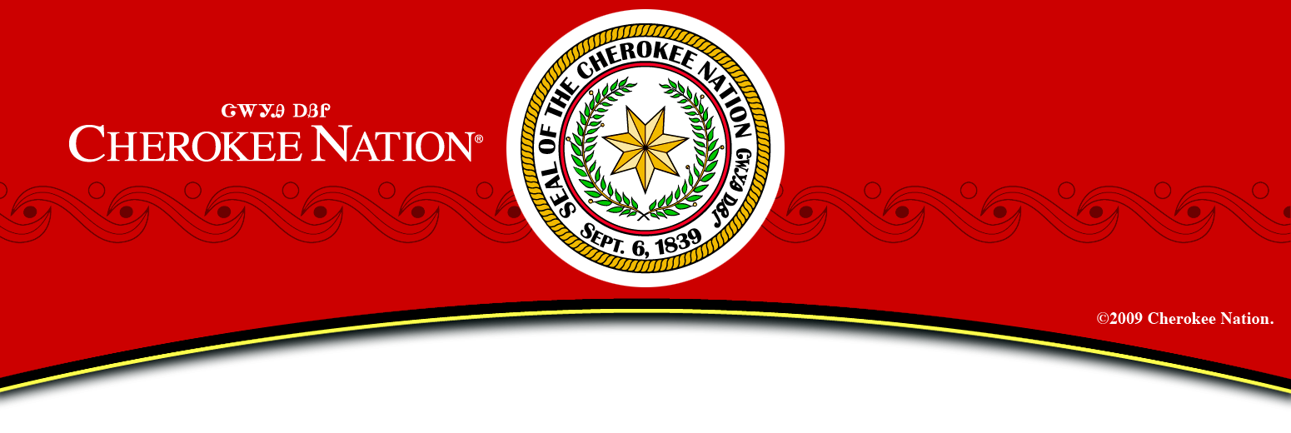
COLLINSVILLE MOONLIGHT 5K
Friday, June 7th, 2013
5K 8:00pm Start / 1K 8:15pm Start
Race will begin and end at Sallee Football Field in Collinsville.
- USATF Certified and Sanctioned
- Medals to top 3 male and female standard age group
- 1st 500 registered will receive a Nike t-shirt
Registration begins at: 6:30 P.M.
5K Pre-Registration $15.00 | 5K Race Day $20.00
1K Pre-Registration $10.00 | 1K Race Day $15.00

Contact information: Ronnie Neal (918)407-3867 or ronnie-neal@cherokee.org

Timed by: TATUR Racing

Mail race entry form to: Cherokee Nation Wings Program, P.O. Box 948, Tahlequah, OK 74465

Proceeds to benefit City Park Improvements. Make checks payable to: City of Collinsville

Name____________________________________ Age on Race Day _______DOB _________Sex_______

Address____________________________________City________________State________Zip_________

Phone______________ Are you a Wings member? ________ T-shirt Size (circle one) S M L XL XXL

Race (circle one) 5 KM Run 1 Mile Fun Run Wings Deadline: May 22, 2013 -Fax (918-458-6224)
I know that running a road race is a potentially hazardous activity. I should not enter and run unless I am medically able and properly trained. I assume any and all risks associated with running this event including, but not limited to falls, contact with other participants, the effects of weather and the conditions of the roads, and all such risks being known and appreciated to me. Furthermore, I understand that I may be running in traffic; and I agree to yield to all emergency vehicles. I am fully aware that baby strollers and wheels of any kind (except competitive wheelchairs), animals and headphones are strictly prohibited and I agree not to have them on the course. Furthermore, I agree not to go back on to the course after finishing. I am fully aware that it is a fraudulent act to switch race numbers with anyone or allow anyone other than myself to wear my race number and I agree not to do this. Knowing these facts, and in consideration of your accepting my entry, I hereby for myself, my heirs, executors, administrators, or anyone else who might claim on my behalf, covenant not to sue, and waive and release and discharge any and all race sponsors, officials, volunteers, local and state police including any and all of their agents, employees, assignees, or anyone acting on or for their behalf from any and all claims or liability for death, personal injury, or property damage of any kind or nature whatsoever arising out of or in the course of my participation in this event whether same be caused by negligence of fault. This release and waiver extends to all claims of every kind or nature whatsoever, foreseen or unforeseen, known or unknown. The undersigned grants permission to sponsors and/or agents authorized by them to use any photos, videotapes, motion pictures, or any other record of this event for any purpose. Refunds will not be given in the event of registered participant no-shows. Signature is required to participate. Minors accepted only with a parent or guardian signature.

Signature: _______________________________ Date: _____________

Parent or Guardian Signature: __________________Date: ______________

